Project Report

Electronic Vendor Database

Group 26

Elijah Wendel

Eric Johnson

PakChung Chang (Andy)

**Application Overview**

This application is an electronics vendor that operates both a website and a chain of many physical stores. There are many different products in each store. This application allows customers to check the inventory online; employees can manage their inventory.

Customers are able to create an account with an email and password. Their information will be stored in the database. Customers with an account can edit their information in the profile. They can check the stock information, purchase history and finish transactions. Customers without an account can finish their transactions with a credit card.

Employees have the access to check and update the stock information. The application will also update the stock information in the database when a product is sold.

ER Diagram[1]:

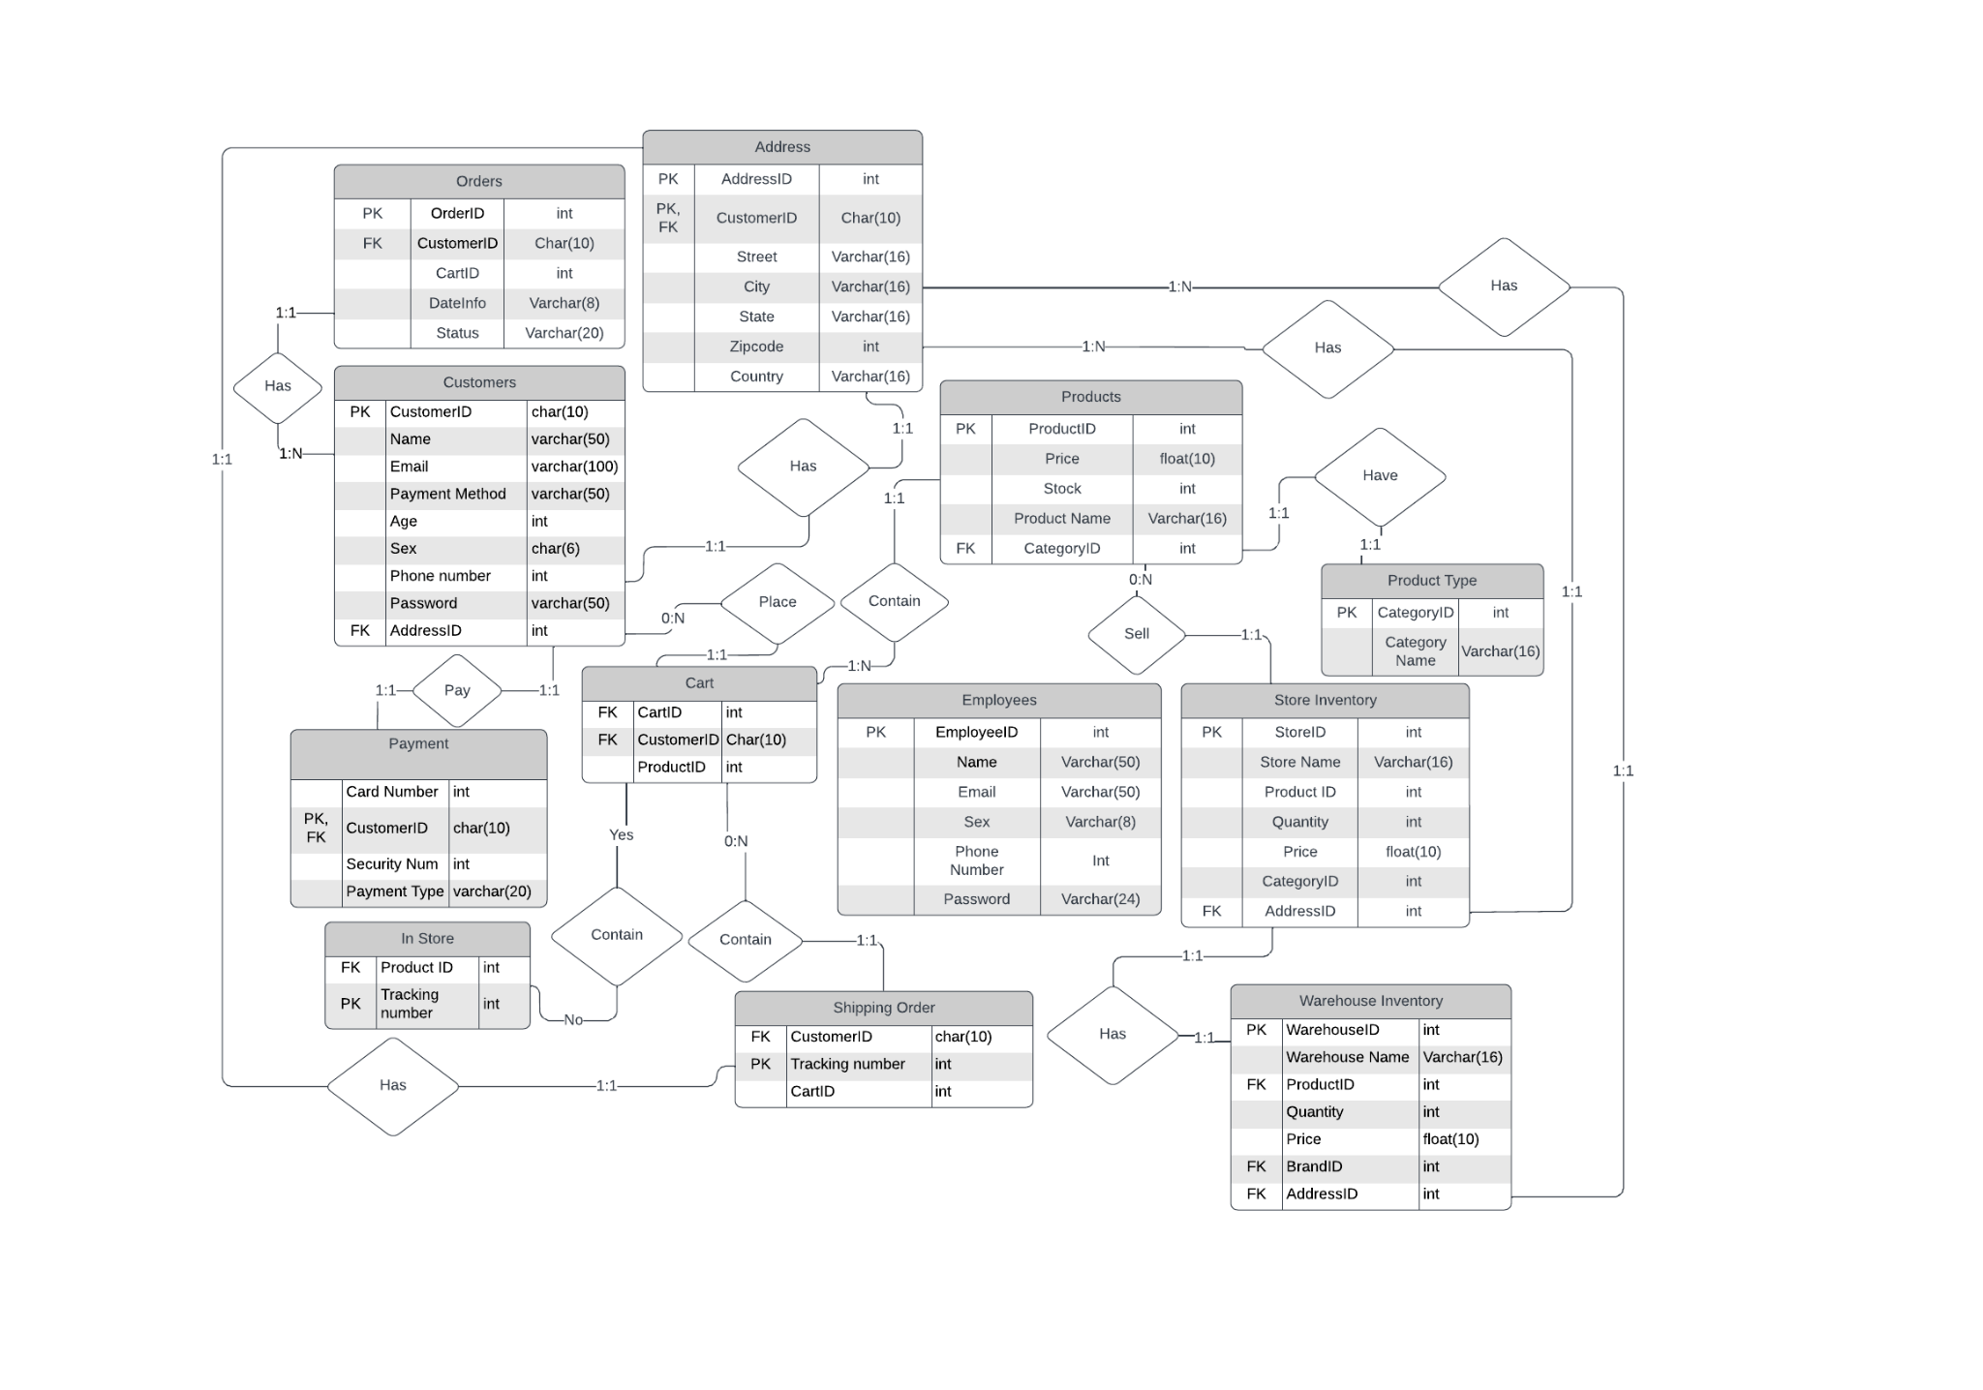

Main menu

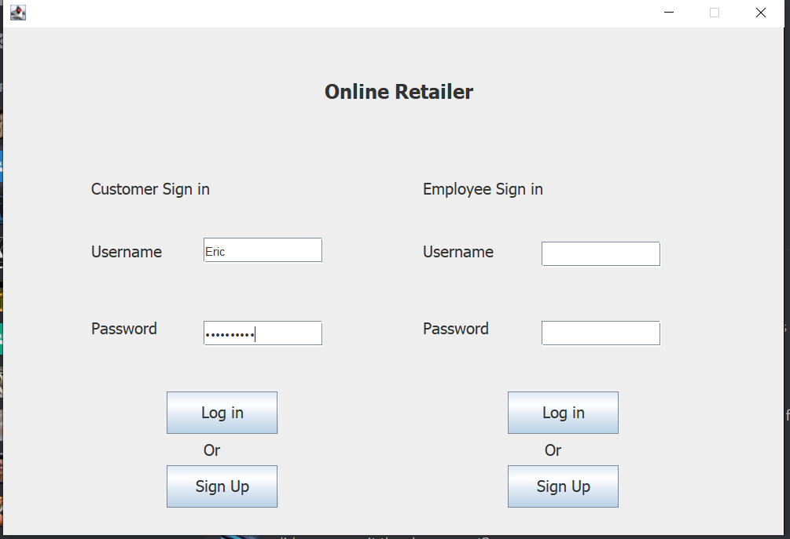

This is the sign-in page for both customers and employees. Customers and employees will both need to sign up before they can start using the system.

Customer Sign Up page

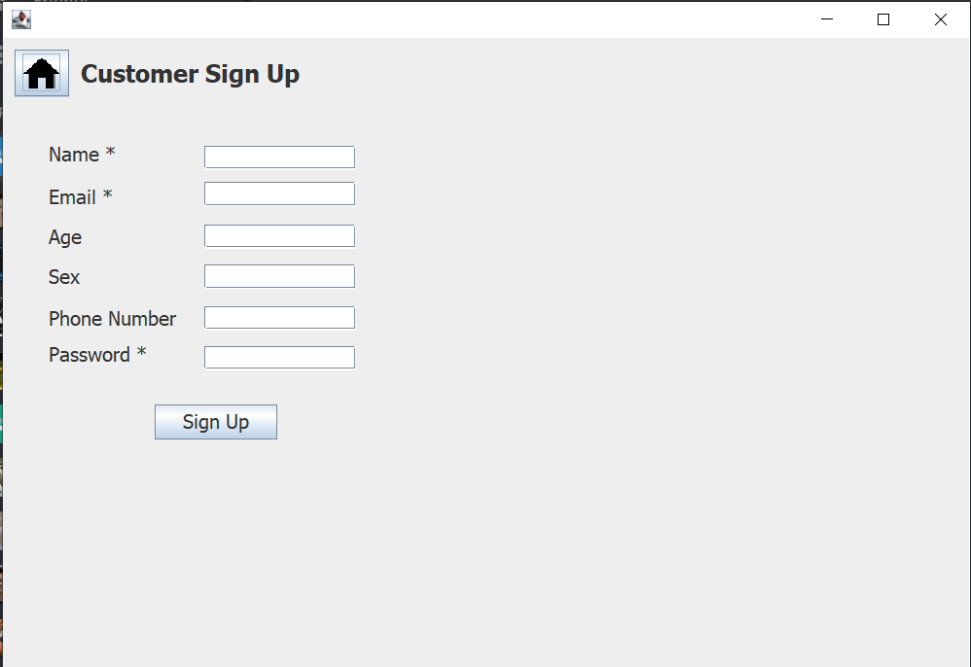

This is the customer sign up page. All information in this page will be stored into the database.

Retailer App

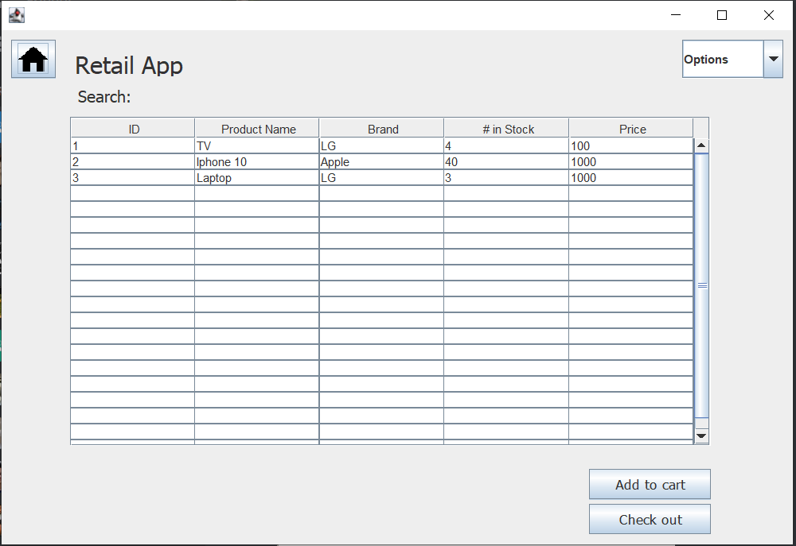

This page will show the ID of products, the product name, brand of product, the number in Stock, price. Customers can add products to the cart by clicking the product and press “add to cart”. After they finish shopping, they can click “check out” to finish their purchase.

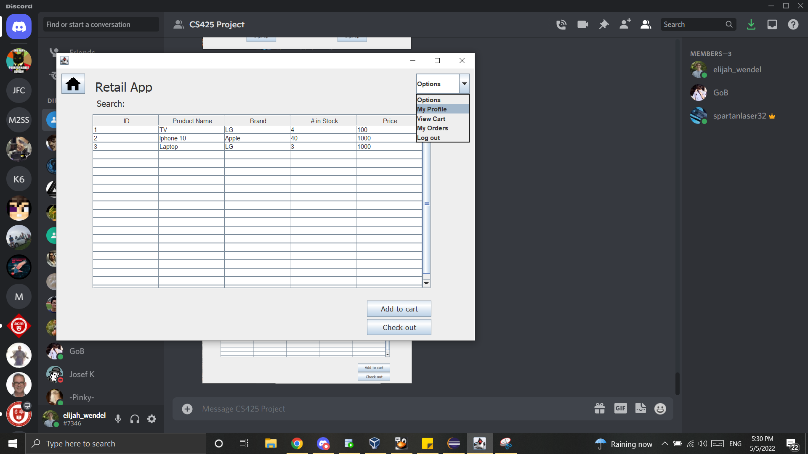

Customers can also click on the top right button and choose to view their profile, view carts, view orders, or log out. This button will be available in other panels too.

Profile page

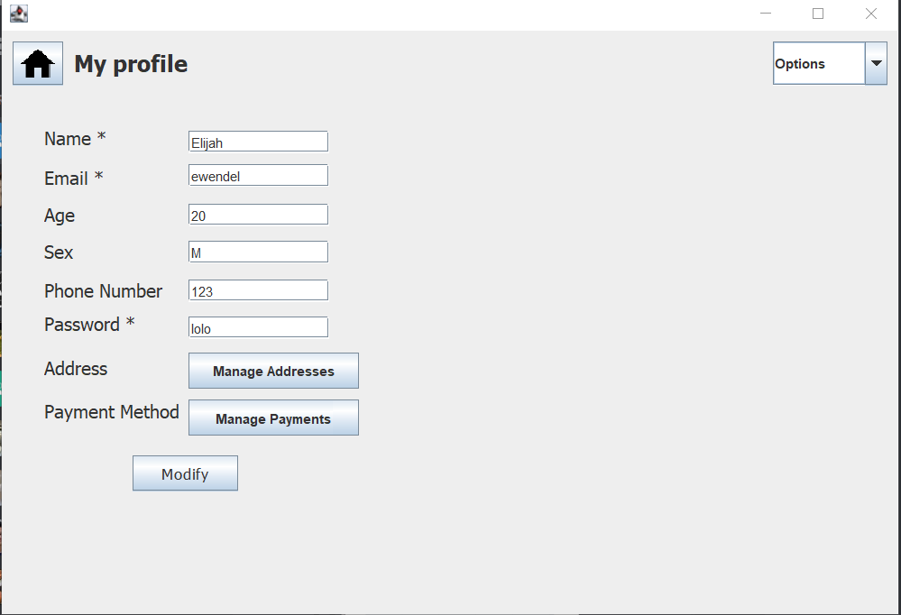

This page allows the customer to edit their information including password.

Address/ Payment Information

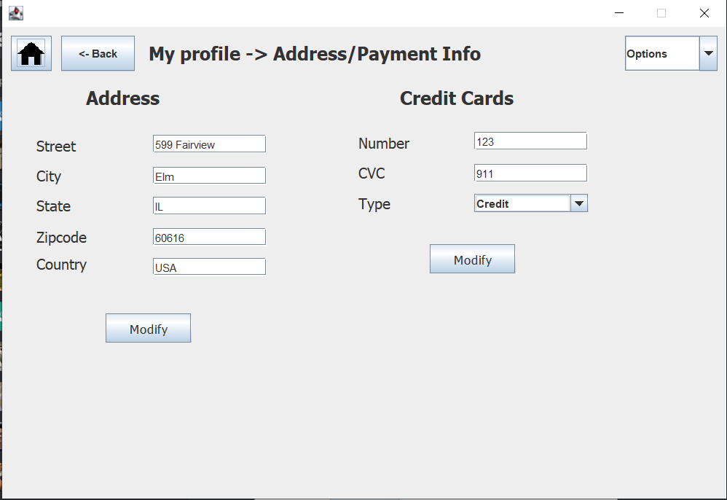

This page will show up after the customer clicks “Manage Addresses” or “Manage Payments”. After inputting their information, they can click “Modify” to complete the changes.

Cart

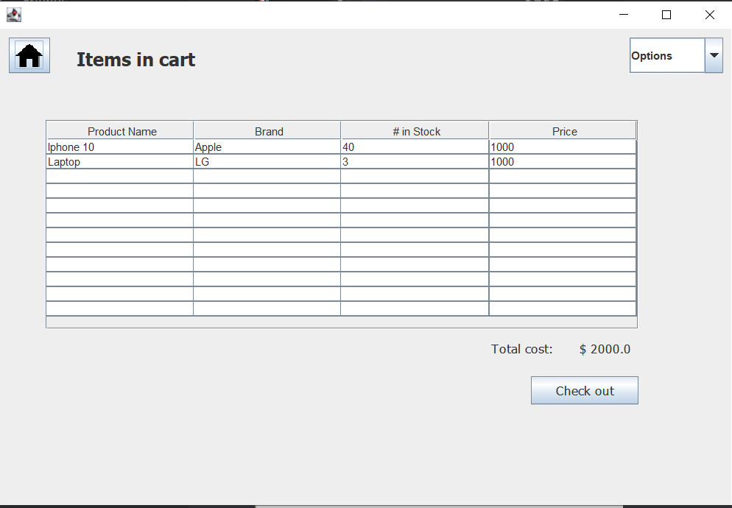

Customers can view their items in cart on this page. The name, brand, number in stock, and price will be listed here. The total price will be shown on the right bottom. They can also press “Check out” to go to the checkout page.

Check out page

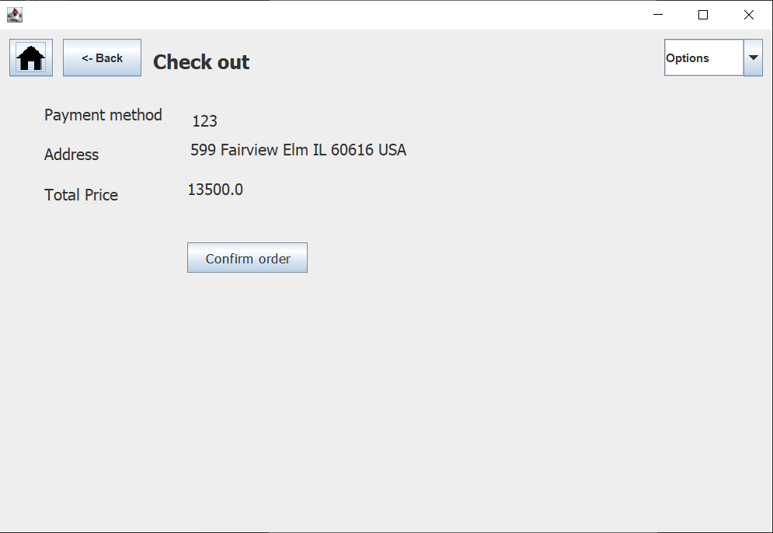

This is the checkout page. Customers can see their payment method, address, and total price here. They can choose to return to last page by clicking “Back” or “Home”, or finish the order by clicking on “Confirm order”.

Employee Sign up page

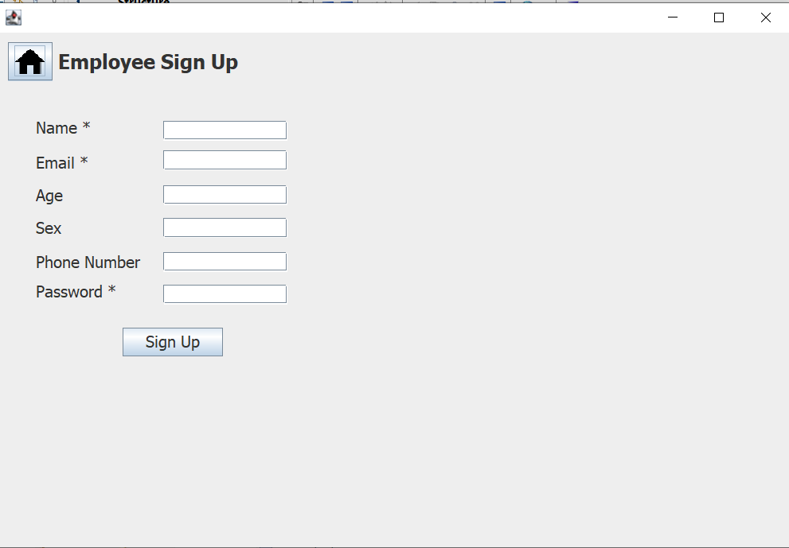

This is the employee sign up page.

Employee page

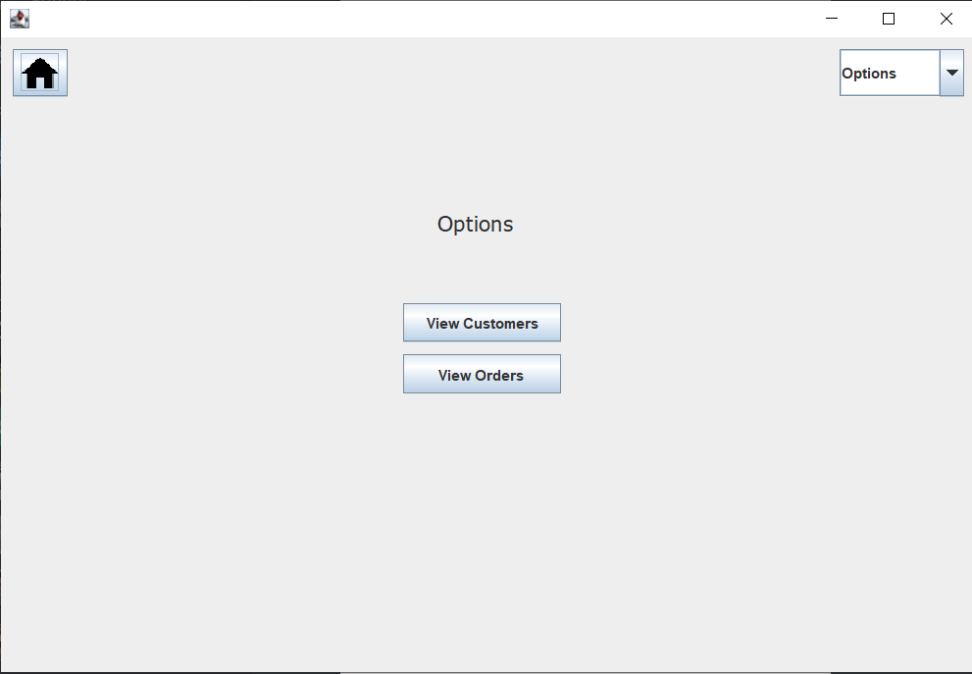

This is the main menu for employees. Employees will be able to view customers and orders, while the customers are only allowed to view orders.

View Customers page

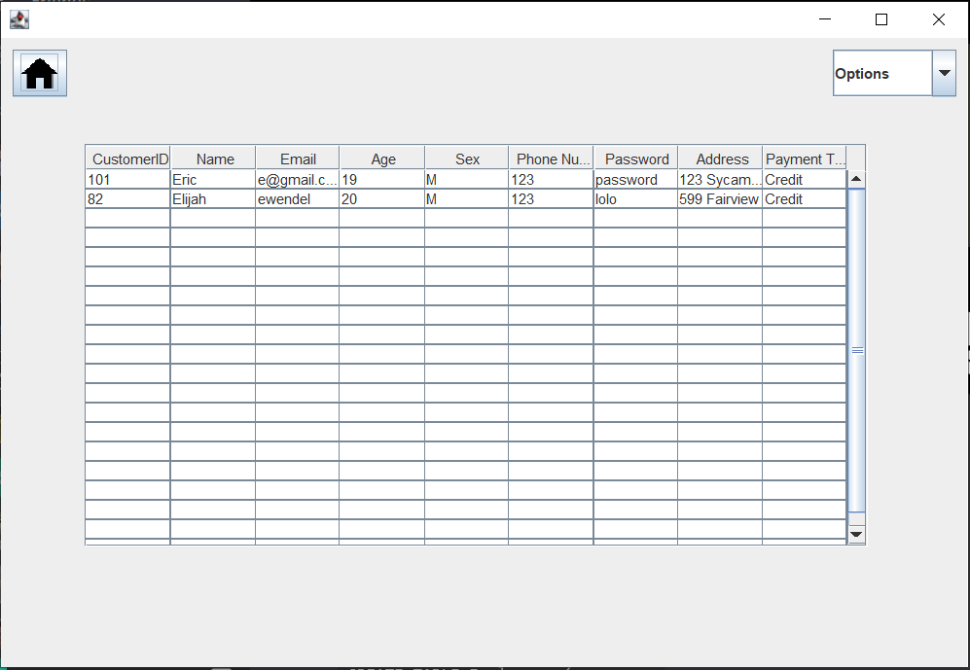

Clicking on the View Customer button, the user can view all of the customers on the database with different attributes and information.

View Orders page

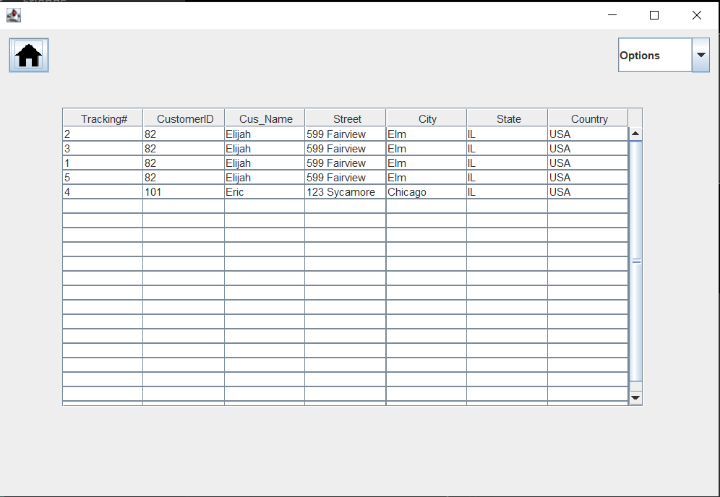

In this page the customer can view all of the orders of all of the customers in the database. This is useful for future improvements of the application as it can be used for customer service.

Video demo link: <https://drive.google.com/drive/folders/1SladFpyiS3xLwqtaYobohHFz64HDHLko?usp=sharing>

1. <https://lucid.app/lucidchart/c668a55b-84d6-4dd3-9940-1b7a9e49cd74/edit?invitationId=inv_203e4c92-6266-45f0-915a-2bd7ec416d43>